# [Flutter Bootcamp Programı | Dart | 2024](https://www.udemy.com/course/flutter-bootcamp-program-dart/) Ödev3

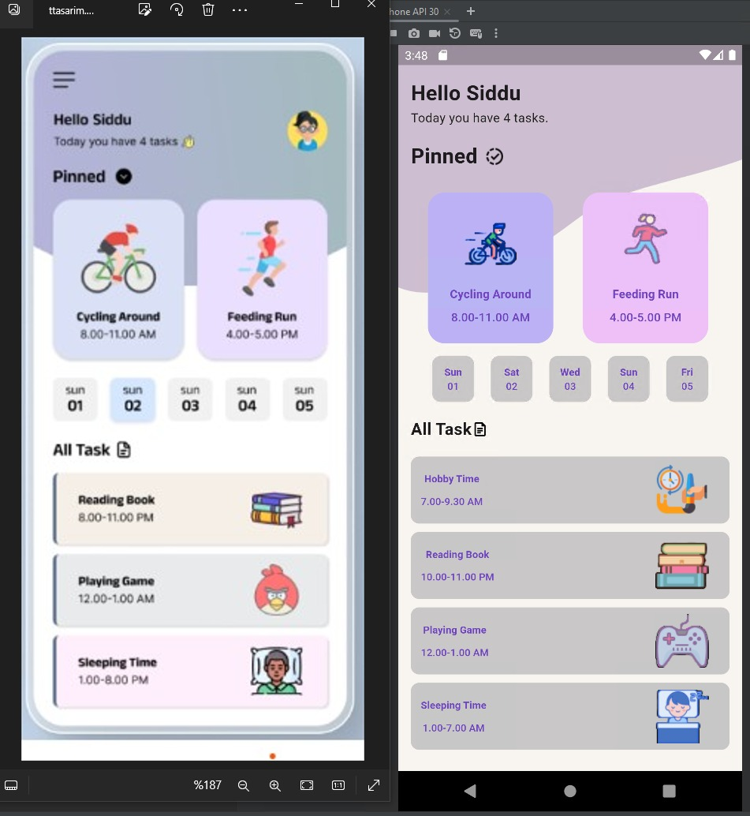

# [Flutter Bootcamp Programı | Dart | 2024](https://www.udemy.com/course/flutter-bootcamp-program-dart/) Bölüm6-7

